**.Net Core Training Final Project Document**

**Once User enters the website, Login page appear, User needs to enter the Username and password.**

**Once you click the login button, the user will be authenticated in the backend if a user exists token will be returned and authorized.**

**API Response:**

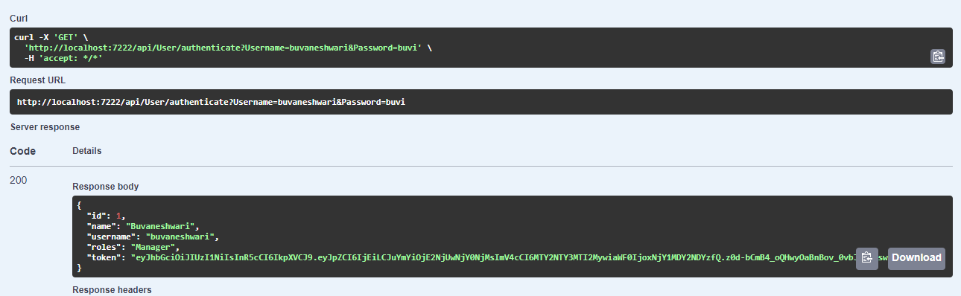

**UI Screen :**

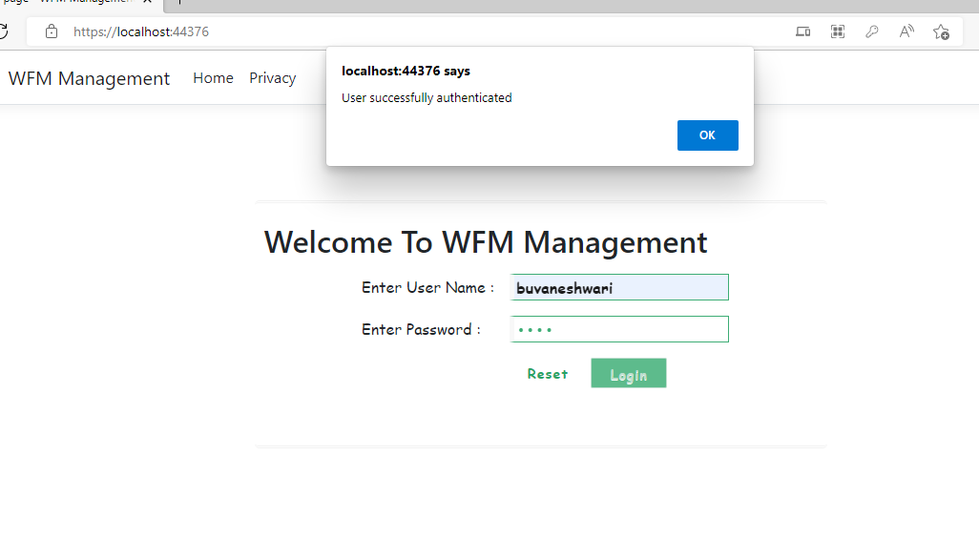

**Based on the user Role , Page will be navigated.**

**If user role is Manager, then it will redirected to EmployeeInfo page**

**UI Screen:**

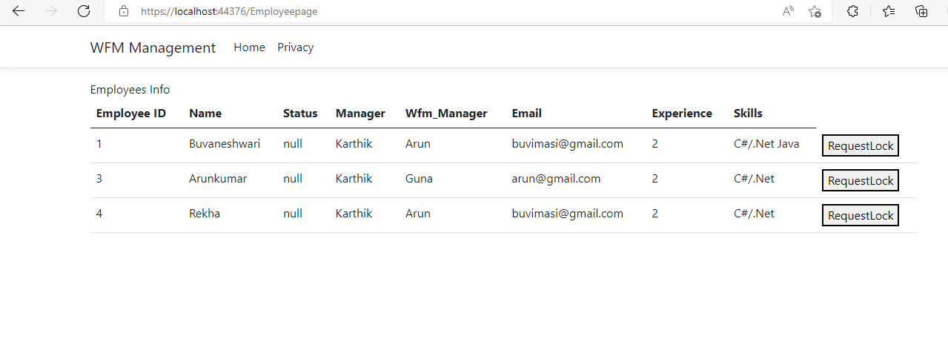

**API Response : (Authenticated by token)**

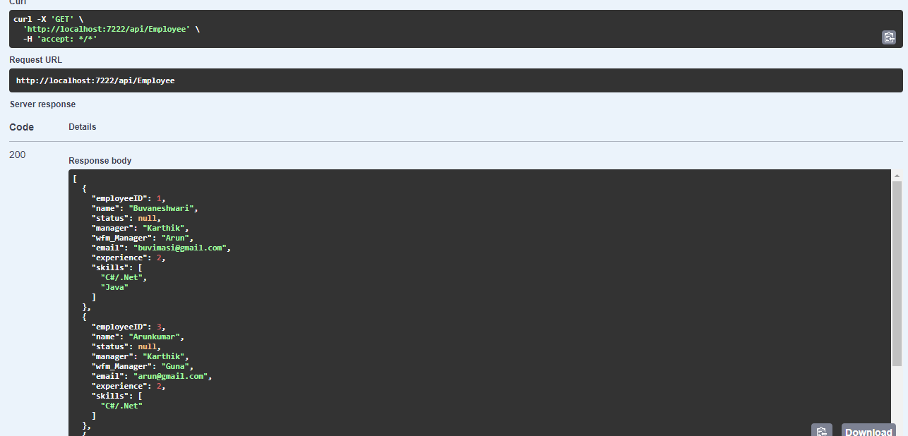

**If user role is Wfm_Member, then it will redirected to SoftLock page**

**UI Screen:**

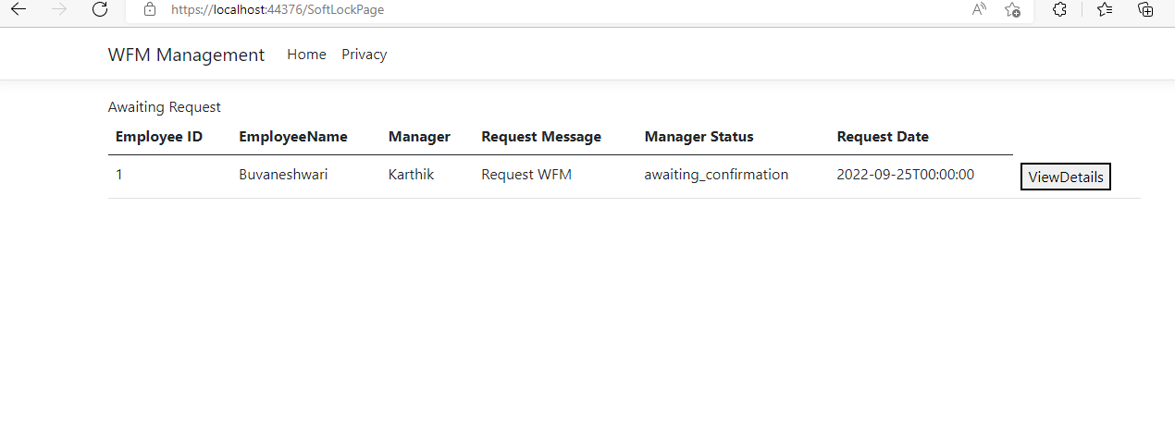

**API Response : (Authenticated by token)**

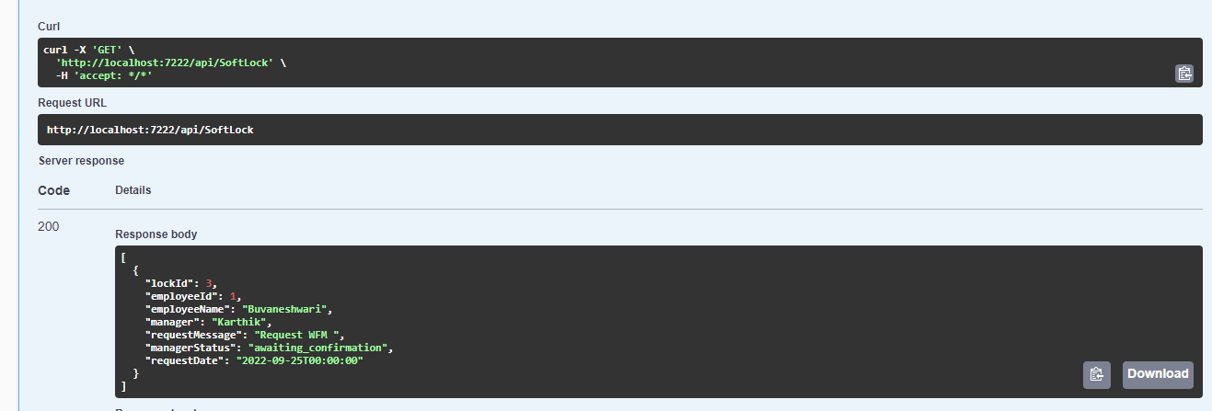

**If the Manager needs to lock the employee, needs to click the Request Lock button in the Employee Page. It will redirected to Softlock Request page**

**UI Screen :**

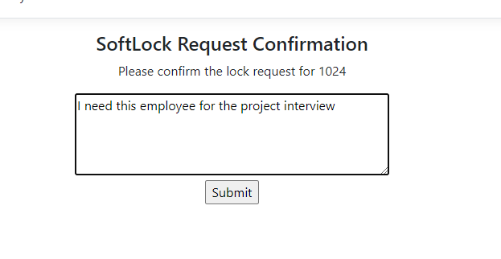

**Once click submit button , Status will be based on Employee table**